**What is sustainability?**

‘Meeting the needs of the present without compromising the ability of future generations to meet their own needs’

For practical ideas, examples of activities and curriculum links, the Early Years Sustainable Hub at  [Early Years Sustainable Hub | ENSFC](https://www.evertonnurseryschoolandfamilycentre.org/early-years-sustainable-hub)  has more information on the 17 Sustainable Development Goals.

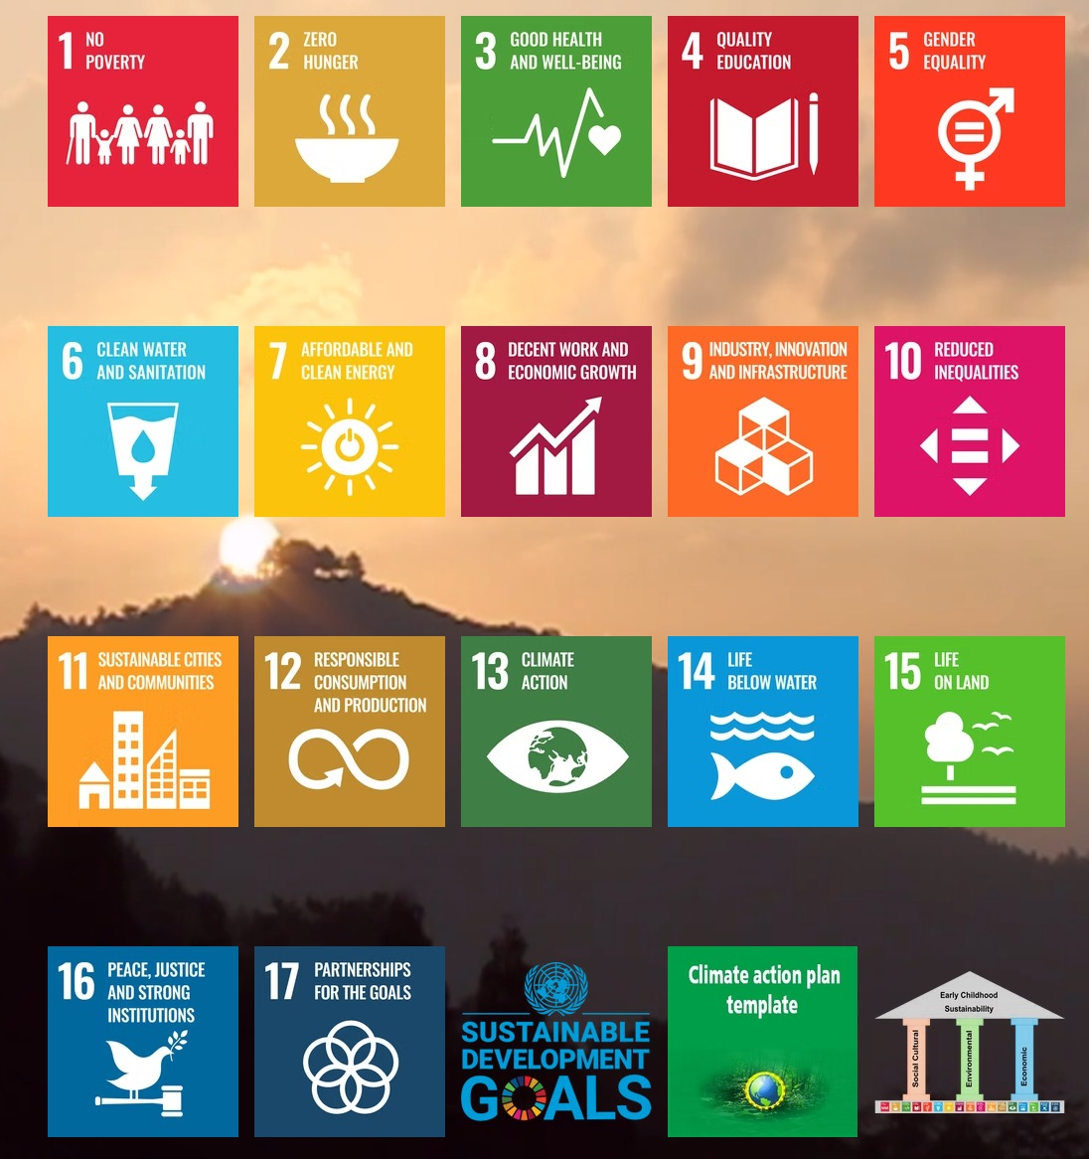

|  |  |  |  |  |  |
| --- | --- | --- | --- | --- | --- |
| **Little Explorers – Climate Action Plan (2024 – 25)**  **Early Years Foundation Stage (DfE,2024, p 9) to “*foster their understanding of our culturally, socially, technologically and ecologically diverse world”.*** | | | | | |
| **Pillar 1: Environmental- Make links to Specific Area “Understanding the World” The Natural World. For example, “*Understand some important processes and changes in the natural world around them, including the seasons and changing states of matter*” (EYFS, DfE, 2024, p 15)** | | | | | |
| What is working well? | Started to work towards the DfE strategy through staff training. | | | | |
| **What is our focus**  **for this term/year?** | **How will we achieve this?**    Linked to DfE Strategy (DfE, 2021) regarding these 3 education points – We will embed pedagogical experiences that enable children to be-   * *passionate about the natural world* * *want to do their best to protect it* * *can influence their wider communities*   Reflect and explore over the year through themed environmental work different projects that work towards | **Associated costs/budget?**      Audit free resources available in county or national – e.g.  Woodland Trust. Audit local support teams such as National Education  Park- [Home |](https://www.educationnaturepark.org.uk/) | **Who will lead on this?**    Whole nursery holistic approach - DfE (2021) “*adopt a* *systems-based approach”* rather “*than focussing on specific age or sectors”.* | **What will success look like?**      Both children and educators starting to feel more confident in environmental conversations and actions. | **Stakeholders’ involvement?**    Children as decision makers working collaboratively with the educators.  Complete involvement of parents and community aspects of the setting. |

|  |  |  |  |  |  |
| --- | --- | --- | --- | --- | --- |
|  | children understanding “*the causes and impacts of climate change and the importance of sustainability”* (DfE, 2021).  Themes include - Place based learning/ Planet through the seasons/ Biodiversity/ Understanding Climate changes and actions / Indigenous learning/Rights of Nature. | [Education Nature](https://www.educationnaturepark.org.uk/)  [Park](https://www.educationnaturepark.org.uk/)  Or Royal  Geographical  /Horticultural Society partners that are part of the  DfE Strategy for  Sustainability-  [National Education](https://www.rgs.org/schools/projects-and-partnerships/national-education-nature-park-and-climate-action-awards)  [Nature Park and](https://www.rgs.org/schools/projects-and-partnerships/national-education-nature-park-and-climate-action-awards)  [Climate Action](https://www.rgs.org/schools/projects-and-partnerships/national-education-nature-park-and-climate-action-awards)  [Awards - RGS](https://www.rgs.org/schools/projects-and-partnerships/national-education-nature-park-and-climate-action-awards) |  |  |  |
| **Examples /planned**  **activities** | **Provocations linked to SDG 3 SDG 4 SDG 11 SDG 13 SDG 14 SDG 15 SDG 17.**    The DfE Strategy asks educators to provide  *“Practical opportunities to participate in*  *activities to increase climate resilience, reduce carbon impact and enhance biodiversity will enable children and young people to translate knowledge into positive action to improve their local communities, their country and the planet”.*    **SDG 3/4/13/14/15** Visit the local area and observe natural habitats. Reflect upon the woodlands from a rights perspective – use images that provoke but not distress, that demonstrate wildlife is dying because of eating plastics (due to humans) rather than their food chain. |  | Whole setting approach with all staff and parents/community involved. | Children engaging in discussions and posing relevant questions and considering solutions. Children’s views considered and heard. Acknowledgement of  children’s self-determination.    Key terminology to be always used from early childhood.    Ensuring opportunities for observation, problem solving, and collaboration. | All children, educators’ parents and community. |

|  |  |  |  |  |  |
| --- | --- | --- | --- | --- | --- |
|  | **SDG 4 / 7 /13/** Discuss the difference between weather and climate. Make a weather chart for a week/month. Can you notice that the weather changes – how can we record different weathers?  Look at the TV weather symbols.    *Online resource* [early-years-sustainabilityhttps://www.ncfe.org.uk/media/xbcbjrfj/early-years-sustainability-resource.pdfresource.pdf](https://www.ncfe.org.uk/media/xbcbjrfj/early-years-sustainability-resource.pdf) |  |  | **Characteristics of Effective**  **Learning**  *Playing and exploring.*  *Active learning. Creating and thinking critically.* |  |

|  |  |  |  |  |  |  |  |
| --- | --- | --- | --- | --- | --- | --- | --- |
| **Pillar 2: Social – Make links to the Characteristics of Effective Learning (EYFS, DfE,2024, p 17) acknowledging and empowering children’s agency to be active participants within their community and culture.**  *Playing and exploring - children investigate and experience things, and ‘have a go’.*  *Active learning - children concentrate and keep on trying if they encounter difficulties and enjoy achievements.*  *Creating and thinking critically - children have and develop their own ideas, make links between ideas, and develop strategies for doing things.* | | | | | | | |
| What is working well? | Great relationships with local intergenerational community groups such as church and stakeholders - strong parental partnerships. | | | | | | |
| **What is our focus**  **for this term/year?** | **How will we achieve this?**    Link to the DfE strategy (2021) to  “*Empower all young people to be global citizens” and* through partnership work with others to “*share objectives and extend and amplify existing good practice and initiatives.”*  Themes include - Intergenerational learning/ Festivals and culture from the community/ Understanding Children’s rights/ Ethics of care for both human and non- human/ Diversity and inclusion for all/ Our community neighbourhood. | **Associated costs/budget?**      Continue to develop strong partnerships and to  access local indigenous knowledge | **Who will lead on this?**      Whole setting approach with all staff and parents/community involved. | | **What will success look like?**    Flowing and led by both children and adults. Strong Intergenerational links culturally and historically within your community.      Children engaging in discussions and posing relevant questions and considering solutions. | | **Stakeholders’ involvement?**      All children, educators’  parents and community |
| **Examples /planned activities** | **Provocations linked to SDG 3 SDG 4 SDG**  **5 SDG 10 SDG 11 SDG 16 SDG 17**    **SDG 4 SDG 11**  Design a map of our community – add the pathways and look at old maps and compare how it has changed.  Design a village of tomorrow using junk modelling and creating maps. |  | Elders from the community to talk to children regarding community spaces |  | | All children, educators’  parents and community | |

|  |  |  |  |  |  |
| --- | --- | --- | --- | --- | --- |
| **Pillar 3: Economic – Support children to develop their knowledge and understanding about the economy and traditional trades.**  **EYFS (DfE,2024, p 14) link to Mathematics (Numerical Patterns)- “*Verbally count beyond 20, recognising the pattern of the counting system”.*** | | | | | |
| **What is working well?** | We take the children out into the community and buy goods using real money, but we need to develop more economic strategies. | | | | |
| **What is our focus for this year?** | *Encourage children to understand all aspects of the DfE strategy (2021) key actions –*   * *green skills and careers* * *the education estate and digital infrastructure* * *operations and supply chains*     Themes include Traditions and  Crafts from the community/  Alternative energy power/ our Local  High Street/ Developing an awareness of Monetary exchanges/Transport systems. | **Associated costs/budget?** | **Who will lead on this?**      Whole setting approach with all staff and parents/community involved. | **What will success look like?**      All aspects highlighted from DfE strategy to be embedded into both policy and practice within setting. Staff, children, parents and community all engaged. Children being involved and observing monetary exchanges.  Handling real money. | **Stakeholders’ involvement?**      Local shopkeepers, trade people, council and all community.    Green skill volunteers to share stories and trade with children, parents and staff. |
| **Examples/planned**  **activities** | **Provocations linked to SDG 1 SDG 2 SDG**  **4 SDG 6 SDG 7 SDG 8 SDG 9 SDG 11 SDG**  **12 SDG 13 SDG 16 SDG 17**    SDG 4 SDG 8- Share discussions with children about costs associated with them and their nursery- Who buys the paints/toys/materials?  SDG 7 SDG 8 SDG 9 SDG 11- Discuss with the children what infrastructure means and brainstorm different methods of travel/transport.  Do an activity where we see which modes of transport are used the most frequently going past nursery;  Pose questions about potential link to renewable energy, SDG 7, ask if children have seen any electric cars/buses- how would they know? |  |  | **Characteristics of Effective**  **Learning are key here**    *Playing and exploring.*  *Active learning.*  *Creating and thinking critically.* |  |